**CS 255 System Design Document Template**

Michael Armstrong

**UML Diagrams**

**UML Use Case Diagram**

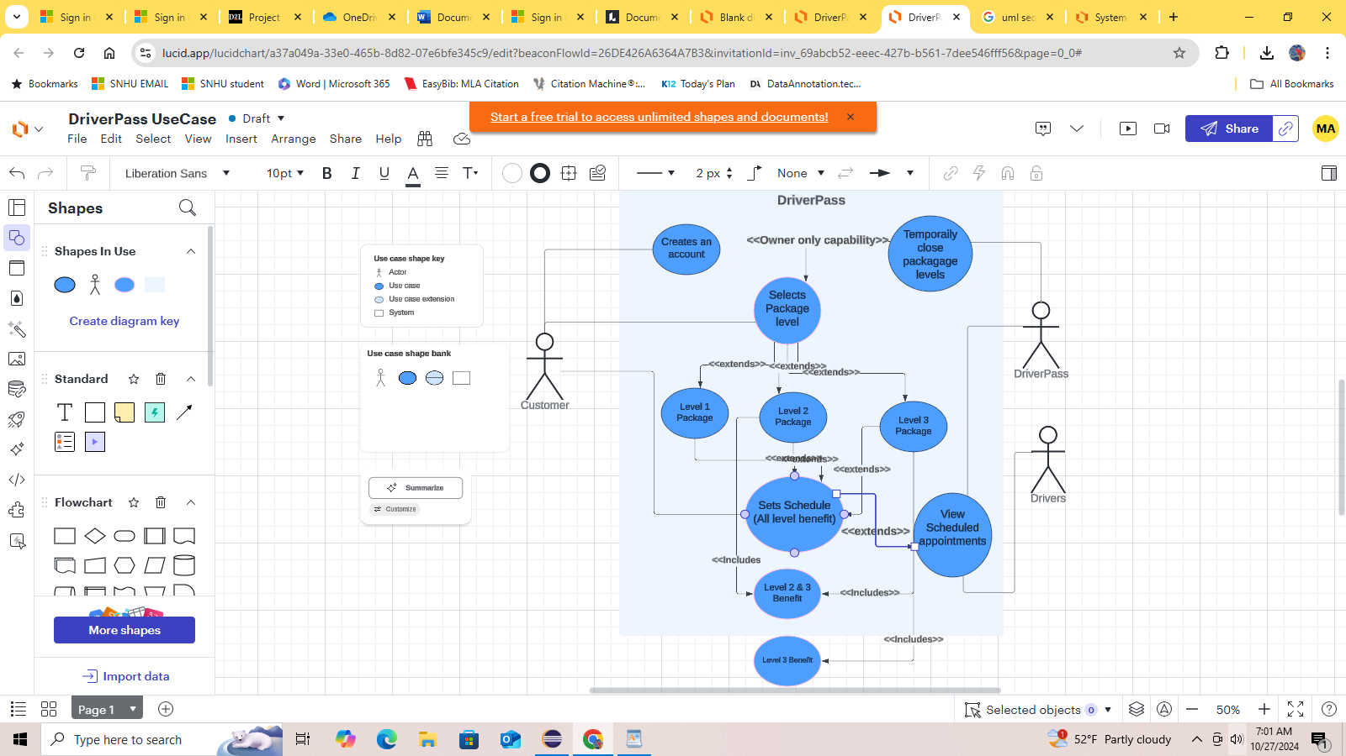

**UML Activity Diagrams**

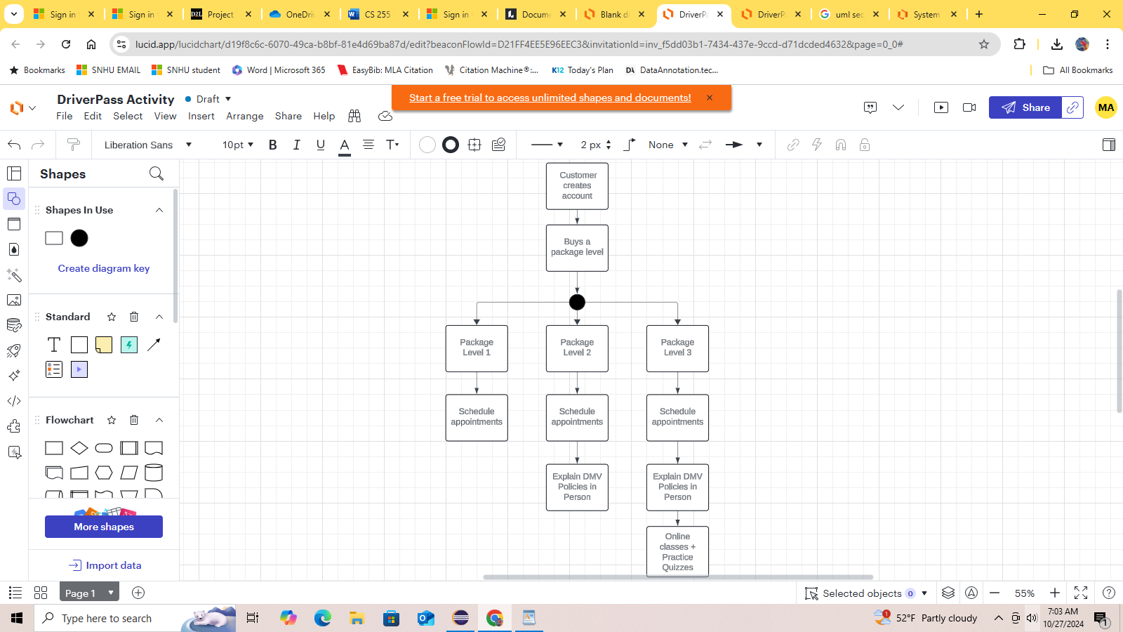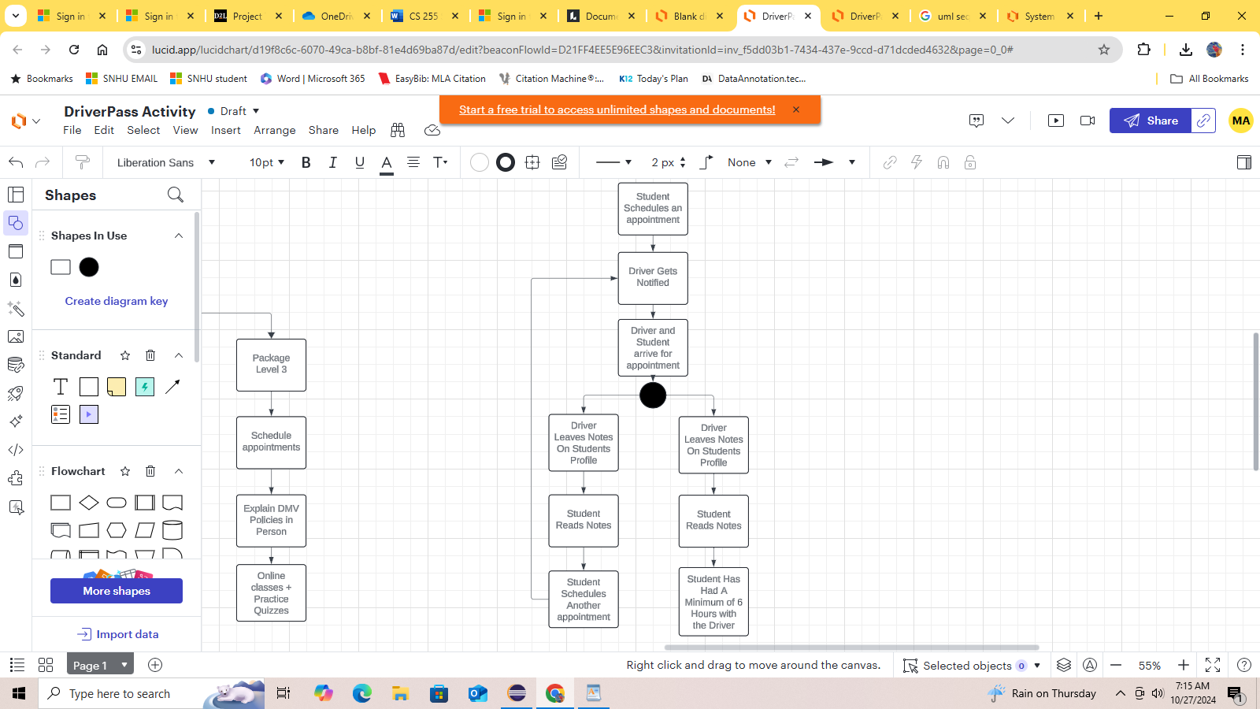

**UML Sequence Diagram**

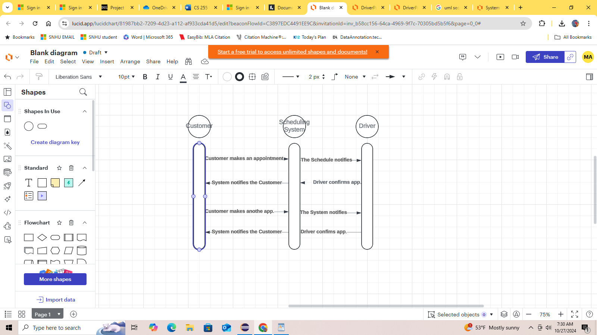

**UML Class Diagram**

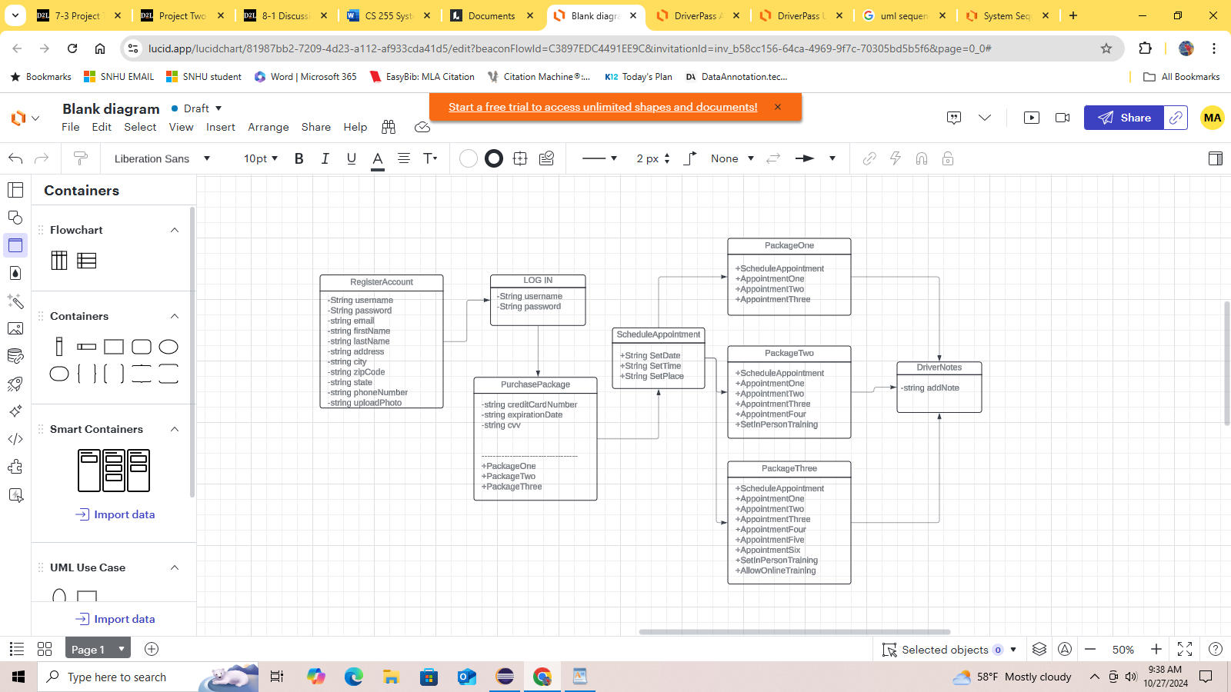

**Technical Requirements**

[Based on the diagrams you have created, describe the technical requirements of your system. These requirements should address the required hardware, software, tools, and infrastructure necessary for your system design.]

This is an online application, so we would need developers who specialize in HTML, CSS, and Java/JavaScript. The Owner wants this to be stored on the cloud, so they don’t need to worry about the service crashing on them, or valuable credit card information being stolen by a cyber attack. This software needs a credit card reading software that links to DriverPass’ bank account.